Tugas Manajemen Basis Data

Materi Transaction

Membuat Query Tabel Account

CREATE TABLE Account(

    ID SERIAL NOT NULL PRIMARY KEY,

    NAME VARCHAR(50) NOT NULL,

    BALANCE INTEGER NOT NULL,

    LAST_UPDATE TIMESTAMP DEFAULT NOW() NOT NULL

)

Membuat Insert Data Database

INSERT INTO Account (NAME,BALANCE) VALUES

('Jasmine',1500000),

('Ariel',500000),

('Belle',300000)

**Non-Repeatable Read**

Non-Repeateable Read using Read Commited

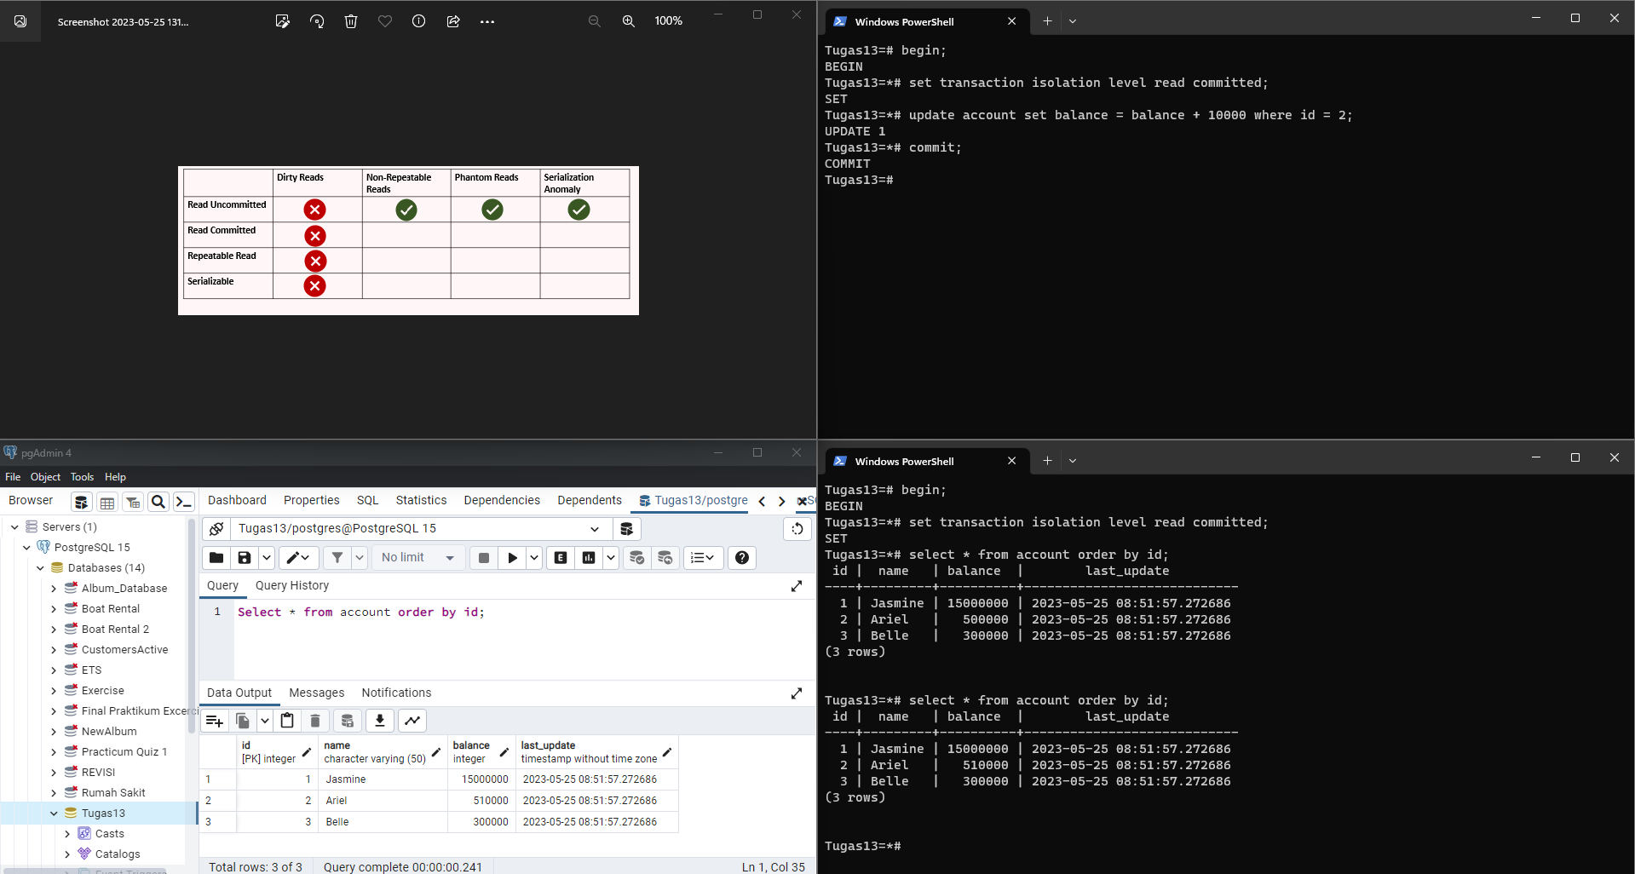

Non-Repeatable Reads using Read Repeatable Read

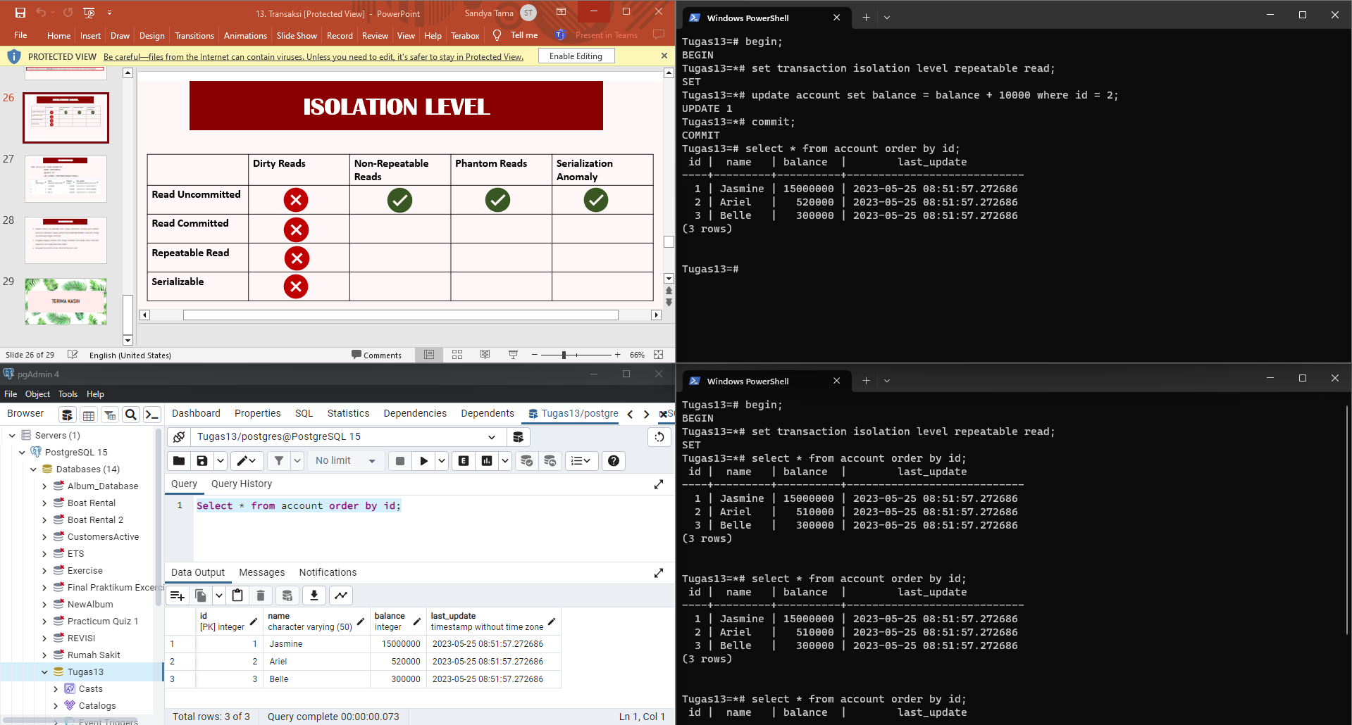

Non-Repeatable Reads using Serializable

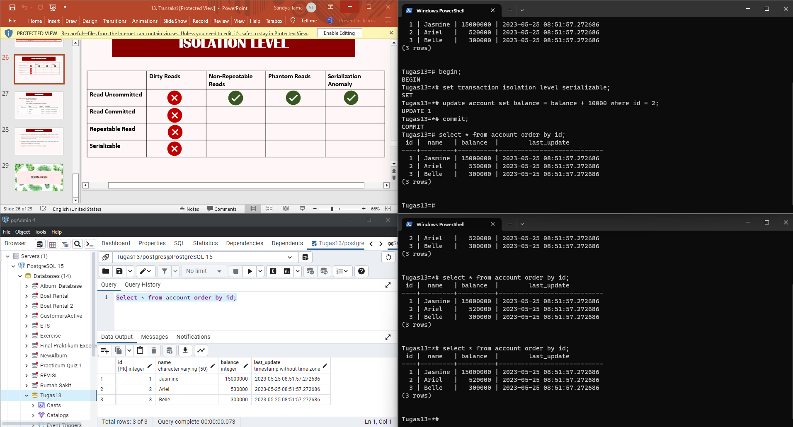

**Phantom Reads**

Phantom Reads using Phantom Read

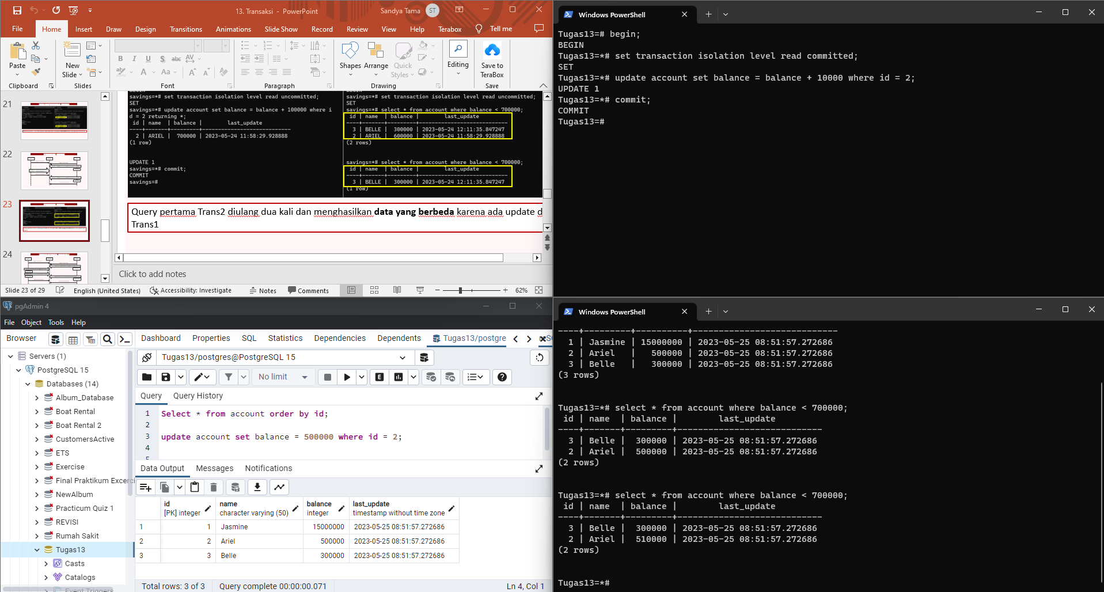

Phantom Reads using Repeatable Read

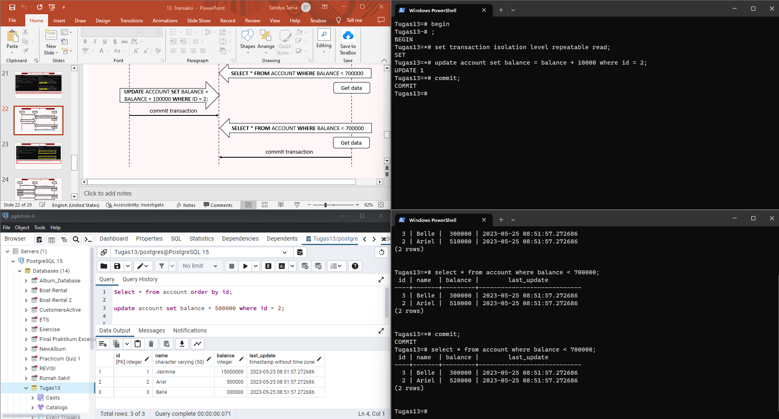

Phantom Reads using Serializable

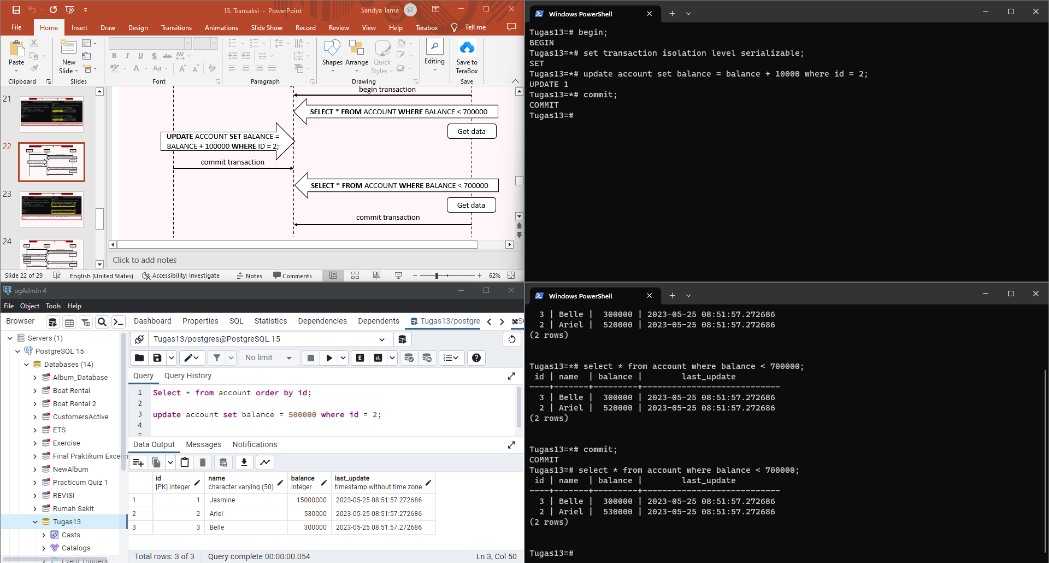

**Serialization Anomaly**

Serialization Anomaly using Read Commited

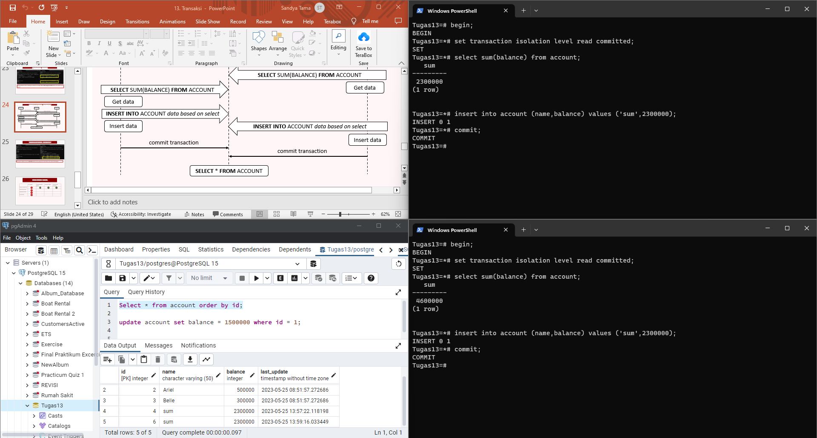

Serialization Anomaly using Repeatable Read

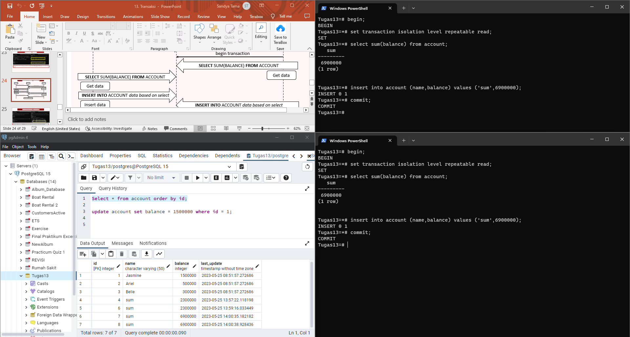

Serialization Anomaly using Serialization

